Topic 2 / Chapter 4

Database Management & CIS 1246

Author: | Christopher Sigouin
Date: | February 2
Date Due: | February 2 (10pm)
Assignment: | Topic 2
 | Task: 1
Mark: ____________

Chapter 3 / Exercises 24, 25, 26, 27, and 28

24. For each table, identify each of the following when possible:

a. The primary key

b. A superkey

c. A candidate key

d. The foreign key(s)

e. A secondary key

CHARTER TABLE
a. Primary Key - CHAR_TRIP
b. Super Key – none
c. Candidate Key – none
d. Foreign Key(s) – CHAR_PILOT, CHAR_COPILOT, AC_NUMBER, CUS_CODE
e. Secondary Key – CHAR_DESTINATION
AIRCRAFT TABLE
a. Primary Key - AC_NUMBER
b. Super Key – none
c. Candidate Key - none
d. Foreign Key(s) – MOD_CODE
e. Secondary Key – AC_TTAF
MODEL
a. Primary Key - MOD_CODE
b. Super Key – none
c. Candidate Key - none
d. Foreign Key(s) – none
e. Secondary Key – MOD_MANUFACTURER
PILOT
a. Primary Key - EMP_NUM
b. Super Key – none
c. Candidate Key - none
d. Foreign Key(s) - none
e. Secondary Key – PIL_LICENSE
CO_PILOT (not shown, but should be identical to PILOT…M:1 with CHARTER & 1:1 with EMPLOYEES)
a. Primary Key - EMP_NUM
b. Super Key – none
c. Candidate Key - none
d. Foreign Key(s) - none
e. Secondary Key – PIL_RATING

EMPLOYEE
a. Primary Key - EMP_NUM
b. Super Key – none
c. Candidate Key - none
d. Foreign Key(s) - none
e. Secondary Key – EMP_FNAME
CUSTOMER
a. Primary Key - CUS_CODE
b. Super Key – none
c. Candidate Key – (CUS_FNAME and CUS_LNAME and CUS_AREACODE and CUS_PHONE)
d. Foreign Key(s) - none
e. Secondary Key – CUS_BALANCE

25. Create the ERD. (Hint: Look at the table contents. You will discover that an AIRCRAFT can fly many CHARTER trips but that each CHARTER trip is flown by one AIRCRAFT, that a MODEL references many AIRCRAFT but that each AIRCRAFT references a single MODEL, and so on.)

An aircraft flies many charters and many charters are flown by one aircraft
A model is used for many aircrafts and many aircrafts have one type of model
A customer takes many charters and many charters are taken by one customer
A pilot takes many charters and many charters are taken by one pilot
A co-pilot takes many charters and many charters are taken by one co-pilot
An employee works as a pilot and a pilot is also one employee
An employee works as a co-pilot and a co-pilot is also one employee

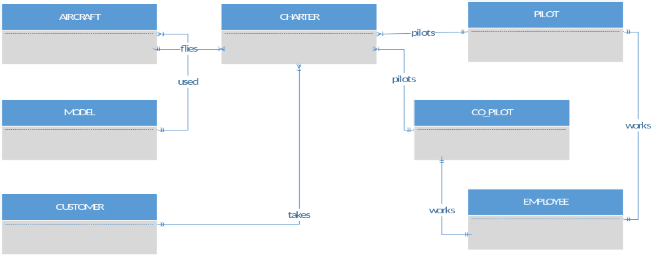

26. Create the relational diagram.

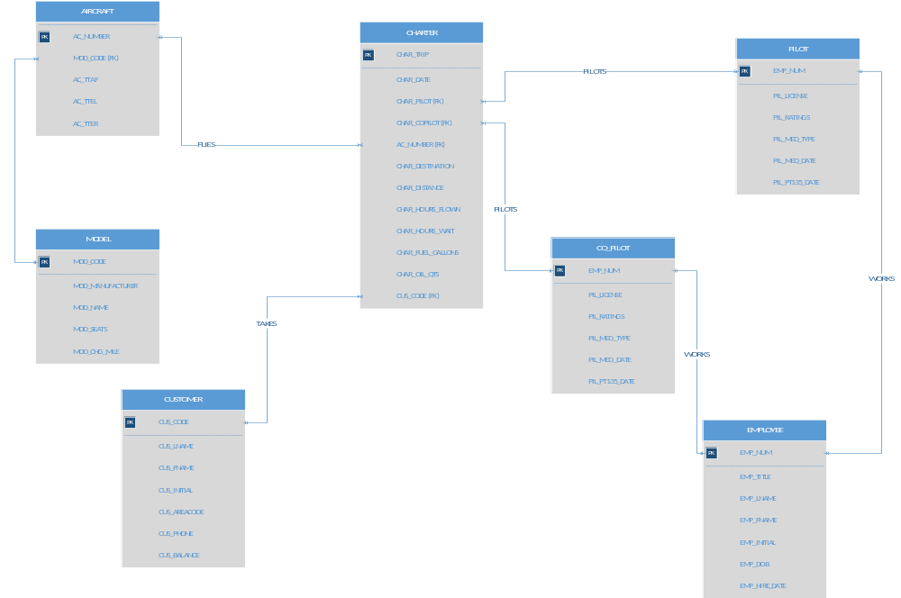

27. Modify the ERD you created in Problem 25 to eliminate the problems created by the use of synonyms. (Hint: Modify the CHARTER table structure by eliminating the CHAR_PILOT and CHAR_COPILOT attributes; then create a composite table named CREW to link the CHARTER and EMPLOYEE tables. Some crew members, such as flight attendants, may not be pilots. That’s why the EMPLOYEE table enters into this relationship.)

An aircraft flies many charters and many charters are flown by one aircraft
A model is used for many aircrafts and many aircrafts have one type of model
A customer takes many charters and many charters are taken by one customer
An employee works as a pilot and a pilot is also one employee
An employee works as a co-pilot and a co-pilot is also one employee
Many crew members direct a charter and a charter is directed by many crew members
Many crew members are designated as an employee and an employee designates many crew members

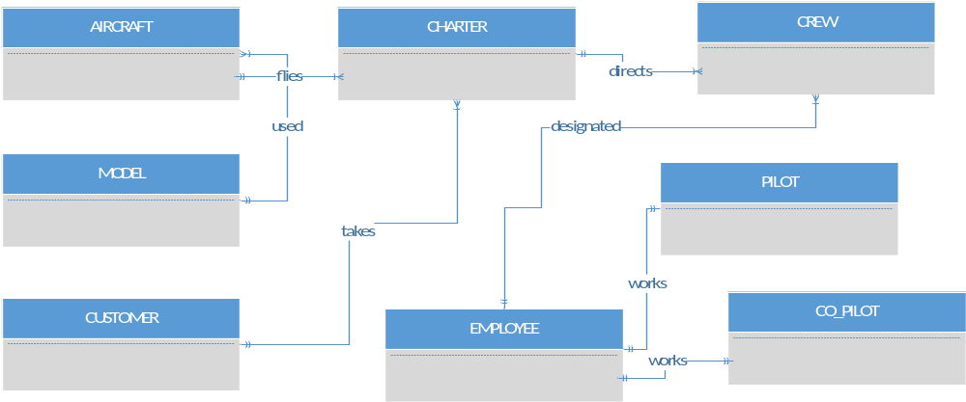

28. Create the relational diagram for the design you revised in Problem 27. (After you have had a chance to revise the design, your instructor will show you the results of the design change, using a copy of the revised database named Ch03_AviaCo_2.)

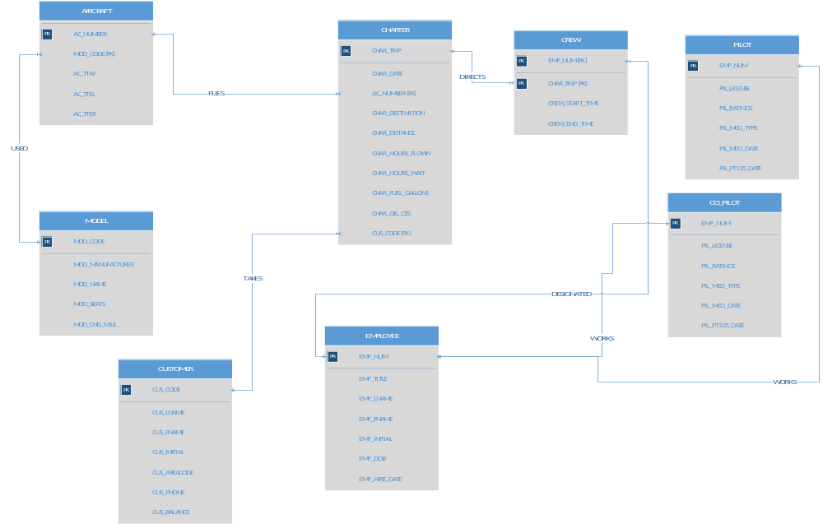

Chapter 4 / Case Problem #10

During peak periods, Temporary Employment Corporation (TEC) places temporary workers in companies. TEC’s manager gives you the following description of the business:

• TEC has a file of candidates who are willing to work.

• Any candidate who has worked before has a specific job history. (Naturally, no job history exists if the candidate has never worked. () Each time the candidate works, one additional job history record is created.

• Each candidate has earned several qualifications. Each qualification may be earned by more than one candidate. (For example, more than one candidate may have earned a Bachelor of Business Administration degree or a Microsoft Network Certification, and clearly a candidate may have earned both a BBA and a Microsoft Network Certification.)

• TEC offers courses to help candidates improve their qualifications.

• Every course develops one specific qualification; however, TEC does not offer a course for every qualification. Some qualifications are developed through multiple courses.

• Some courses cover advanced topics that require specific qualifications as prerequisites. Some courses cover basic topics that do not require any prerequisite qualifications. A course can have several prerequisites. A qualification can be a prerequisite for more than one course.

• Courses are taught during training sessions. A training session is the presentation of a single course. Over time, TEC will offer many training sessions for each course; however, new courses may not have any training sessions scheduled right away.

• Candidates can pay a fee to attend a training session. A training session can accommodate several candidates, although new training sessions will not have any candidates registered at first.

• TEC also has a list of companies that request temporaries.

• Each time a company requests a temporary employee, TEC makes an entry in the Openings folder. That folder contains an opening number, a company name, required qualifications, a starting date, an anticipated ending date, and hourly pay.

• Each opening requires only one specific or main qualification.

• When a candidate matches the qualification, the job is assigned, and an entry is made in the Placement Record folder. The folder contains such information as an opening number, a candidate number, and the total hours worked. In addition, an entry is made in the job history for the candidate.

• An opening can be filled by many candidates, and a candidate can fill many openings.

• TEC uses special codes to describe a candidate’s qualifications for an opening. The list of codes is shown in Table P4.10.

CODE DESCRIPTION
SEC-45 Secretarial work; candidate must type at least 45 words per minute
SEC-60 Secretarial work; candidate must type at least 60 words per minute
CLERK General clerking work
PRG-VB Programmer, Visual Basic
PRG-C++ Programmer, C++
DBA-ORA Database Administrator, Oracle
DBA-DB2 Database Administrator, IBM DB2
DBA-SQLSERV Database Administrator, MS SQL Server
SYS-1 Systems Analyst, level 1
SYS-2 Systems Analyst, level 2
NW-NOV Network Administrator, Novell experience
WD-CF Web Developer, ColdFusion

TEC’s management wants to keep track of the following entities:
COMPANY, OPENING, QUALIFICATION, CANDIDATE, JOB_HISTORY, PLACEMENT, COURSE, and SESSION. Given that information, do the following:

a. Draw the Crow’s Foot ERDs for this enterprise.
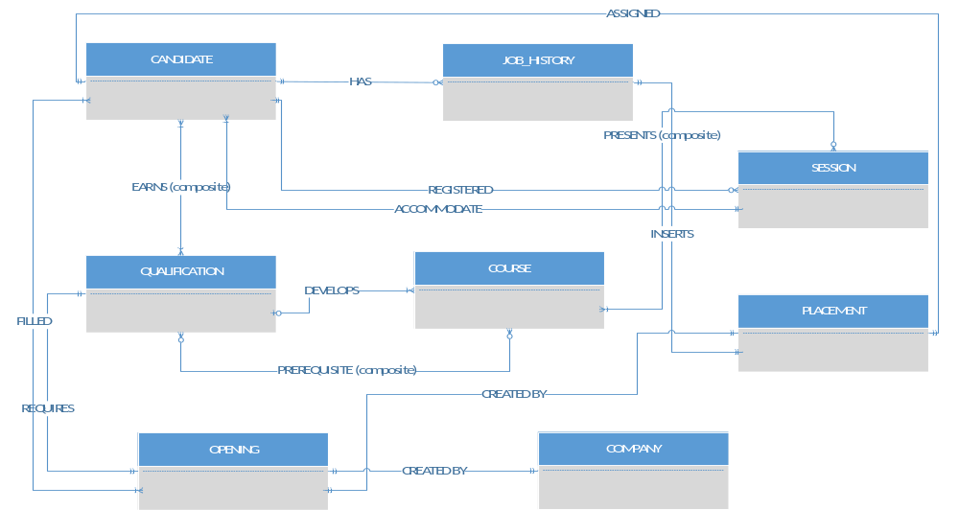

b. Identify all necessary relationships. ( SEE CHART UNDER SECTION C )

c. Identify the connectivity for each relationship.

ENTITY | RELATIONSHIP | CONNECTIVITY | ENTITY
CANDIDATE | has | 0:M | JOB_HISTORY
CANDIDATE | earns / earned by | M:N | QUALIFICATION
COURSE | develops | 0:1 | QUALIFICATION
QUALIFICATION | developed by | 1:M | COURSE
COURSE | has a prerequisite / has a prerequisite | M:N | QUALIFICATION
SESSION | presents / presented by | M:N | COURSE
SESSION | accommodate | 1:M | CANDIDATE
CANDIDATE | be registered for | 0:M | SESSION
OPENING | created by | 1:1( should be 0:1)  company doesn't have to list an opening. Opening requires a company | COMPANY
OPENING | require | 1:1( should be M:1)  A qualification can match many openings | QUALIFICATIONS
PLACEMENT | created by | This is the composite for opening and candidate | OPENING
PLACEMENT | assigned to | This is the composite for opening and candidate | CANDIDATE
PLACEMENT | inserts an entry | 0:1(optional to history b/c there may be history in JOB_HISTORY prior to being a temp worker ) | JOB_HISTORY
OPENING | filled by / can fill | M:N | CANDIDATE

d. Identify the mandatory and optional dependencies for the relationships.

ENTITY | MANDATORY / OPTIONAL DEPENDENCY | ENTITY
CANDIDATE | CANDIDATE has JOB_HISTORY: Optional  JOB_HISTORY has CANDIDATE: Mandatory | JOB_HISTORY
CANDIDATE | CANDIDATE earns QUALIFICATION: Mandatory  QUALIFICATION earned by CANDIDATE: Mandatory | QUALIFICATION
COURSE | COURSE develops QUALIFICATION: Optional  QUALIFICATION developed by COURSE: Mandatory | QUALIFICATION
COURSE | COURSE is prerequisite QUALIFICATION: Optional  QUALIFICATION is prerequisite COURSE: Optional | QUALIFICATION
SESSION | SESSION presents COURSE: Mandatory  COURSE presented by SESSION: Optional | COURSE
SESSION | SESSION accommodates CANDIDATE: Mandatory  CANDIDATE registers for SESSION: Optional | CANDIDATE
OPENING | OPENING created by COMPANY: Mandatory  COMPANY creates OPENING: Mandatory | COMPANY
OPENING | OPENING has a required QUALIFICATION: Mandatory  QUALIFICATION can fit many OPENING: Mandatory | QUALIFICATION
PLACEMENT | OPENING creates PLACEMENT: Mandatory  PLACEMENT created by OPENING: Mandatory | OPENING
PLACEMENT | PLACEMENT assigned to CANDIDATE: Mandatory  CANDIDATE is assigned PLACEMENT: Mandatory | CANDIDATE
PLACEMENT | PLACEMENT inserts entry JOB_HISTORY: Mandatory  JOB_HISTORY inserted by PLACEMENT: Mandatory | JOB_HISTORY
OPENING | OPENING filled by CANDIDATE: Mandatory  CANDIDATE can fill OPENING: Mandatory | CANDIDATE

e. Resolve all M:N relationships.

There are four M:N relationships I identified.

**** MISSING ENROLL BETWEEN SESSION AND CANDIDATE

CANDIDATE – QUALIFICATION
(CREATE ENTITY: WORKER) EDUCATION
COURSE – QUALIFICATION
(CREATE ENTITY: PREREQUISITES)
SESSION – COURSE
(CREATE ENTITY: PRESENTATOR)
OPENING – CANDIDATE
(USE ENTITY: PLACEMENT)
The relationship between opening and candidate dictates that a placement
can be established or “ filled by “. Connectivity’s for the entities
would change accordingly for OPENING and CANDIDATE. JOB_HISTORY
will remain the same.

